**Tutorial for the exe file**

Recommendations: 1) Run the file as administrator

2) Keep the input images in a common directory

**Binary threshold**

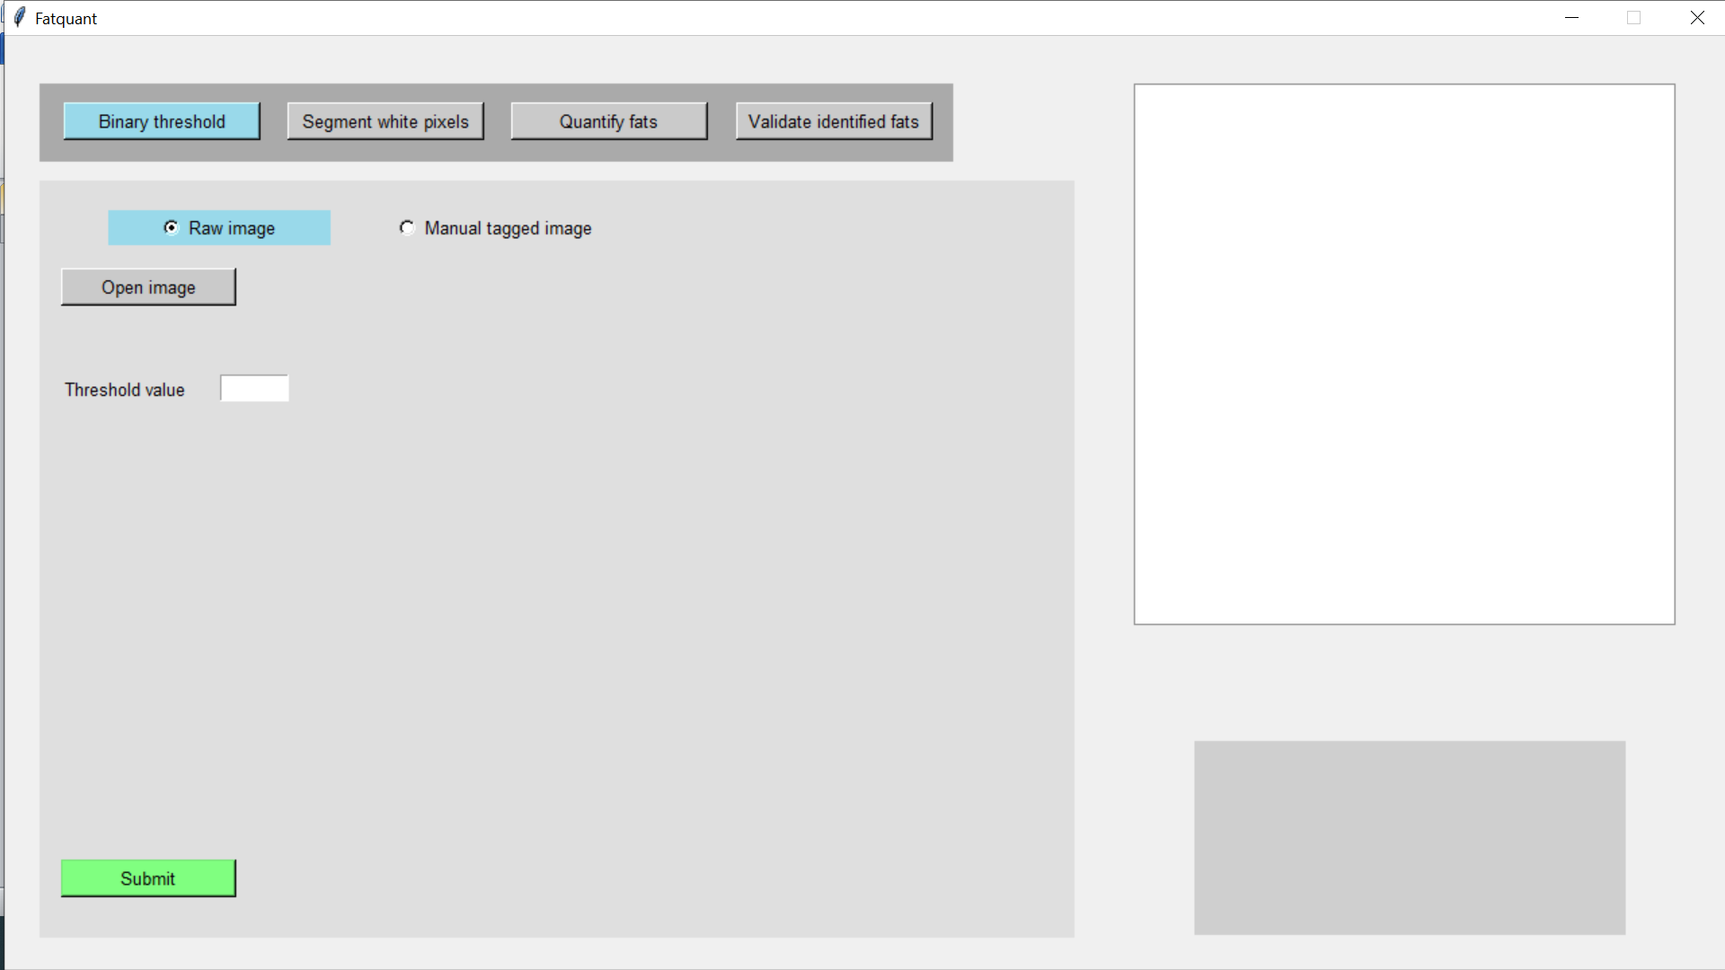

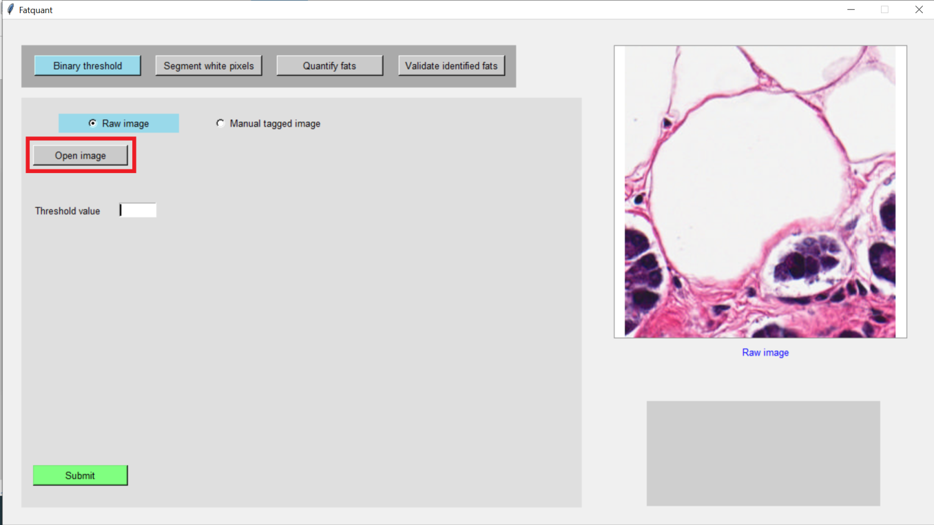

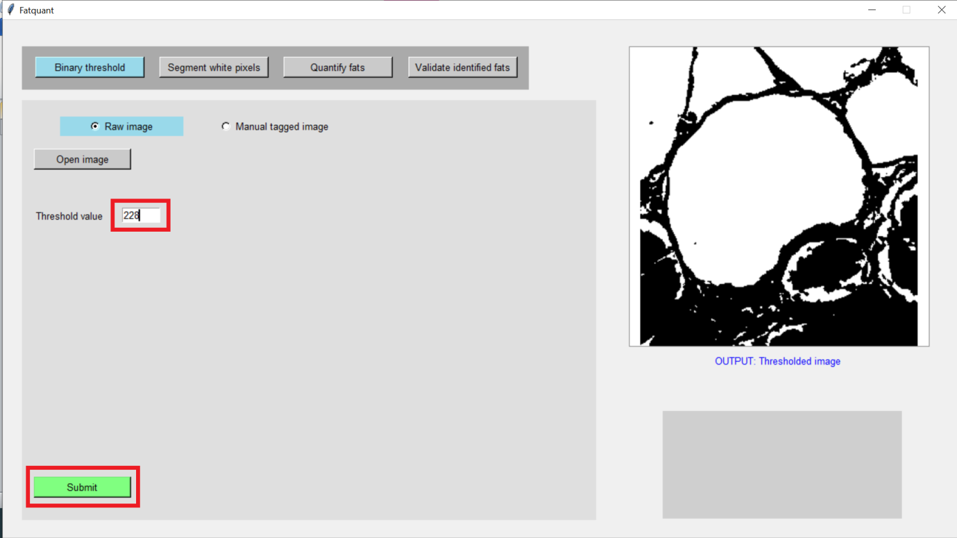

(If ground truth data is available then perform the 2 steps below)

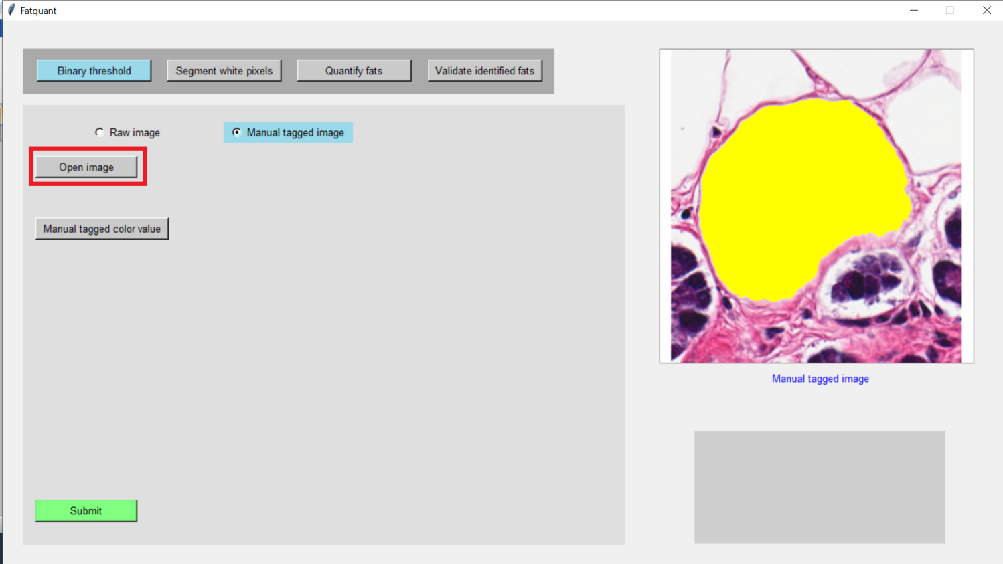

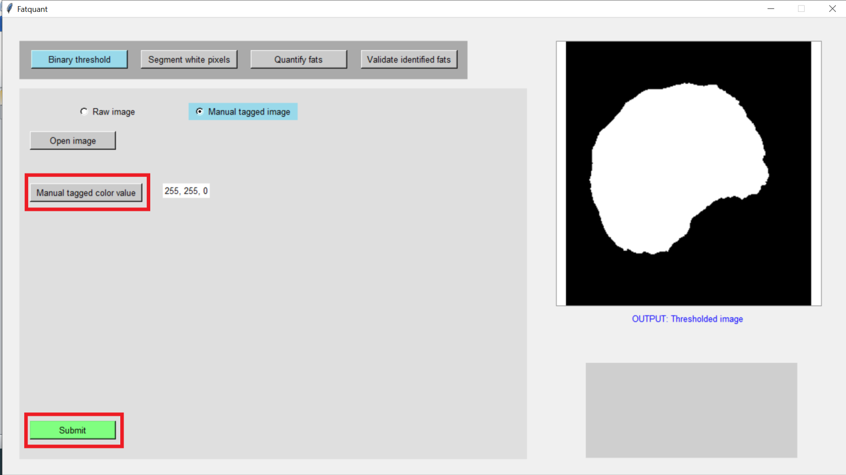

**Segment white pixels**

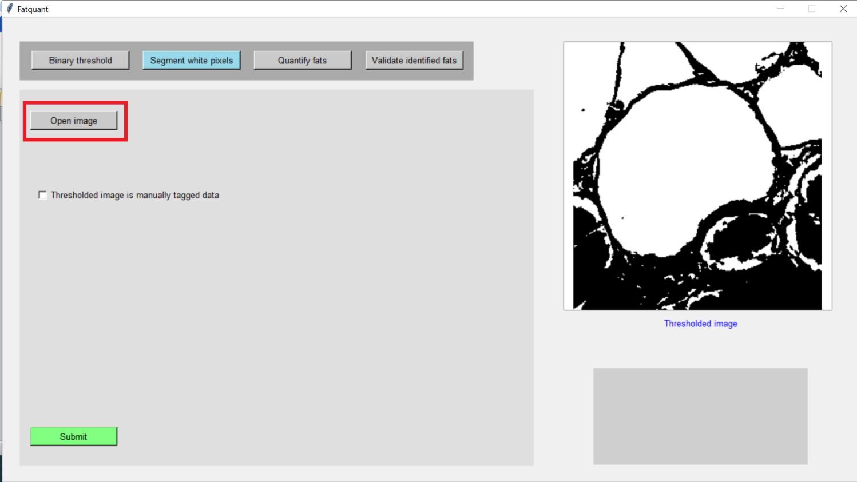

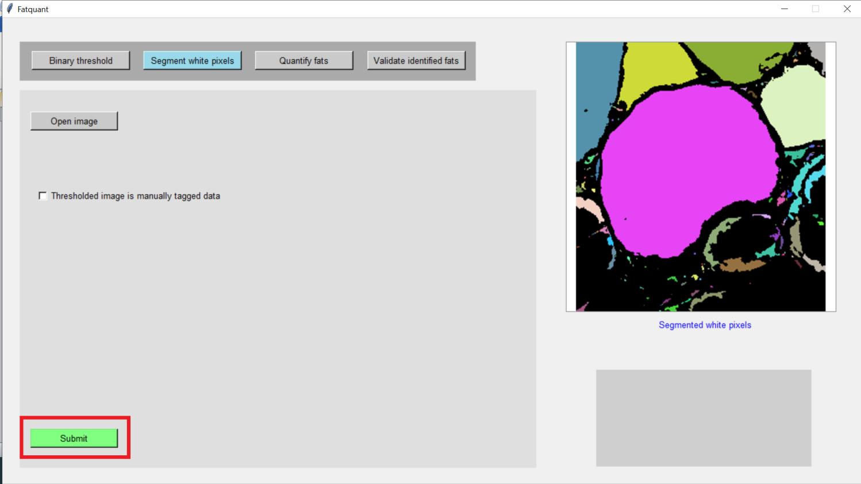

(If ground truth data is available and binary thresholding has been applied on it then perform the 2 steps below)

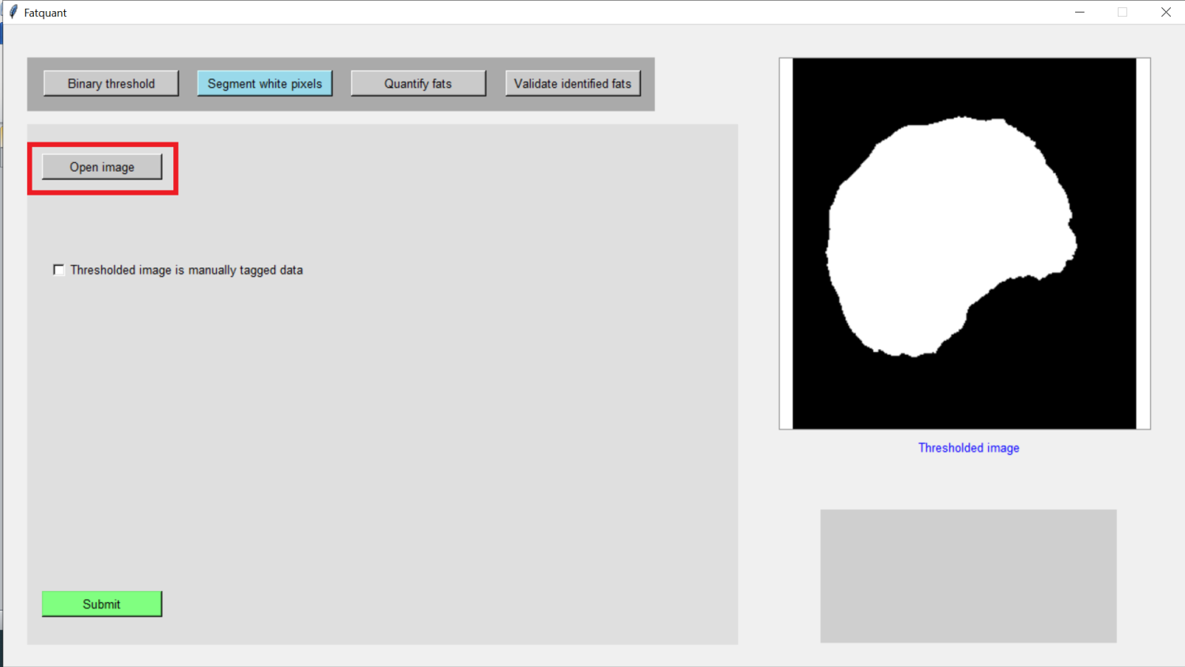

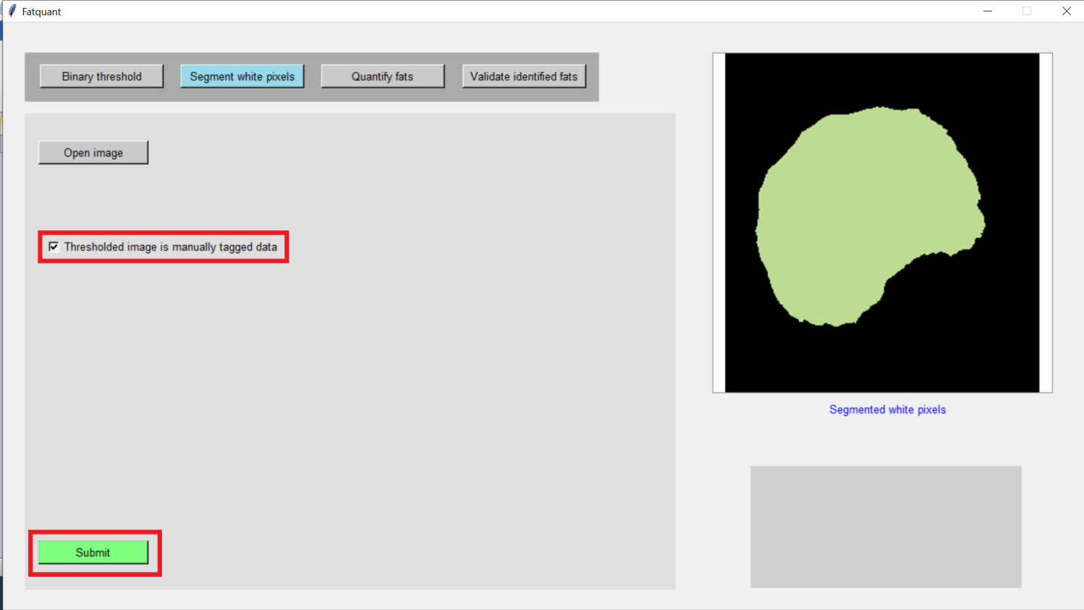

**Quantify fats**

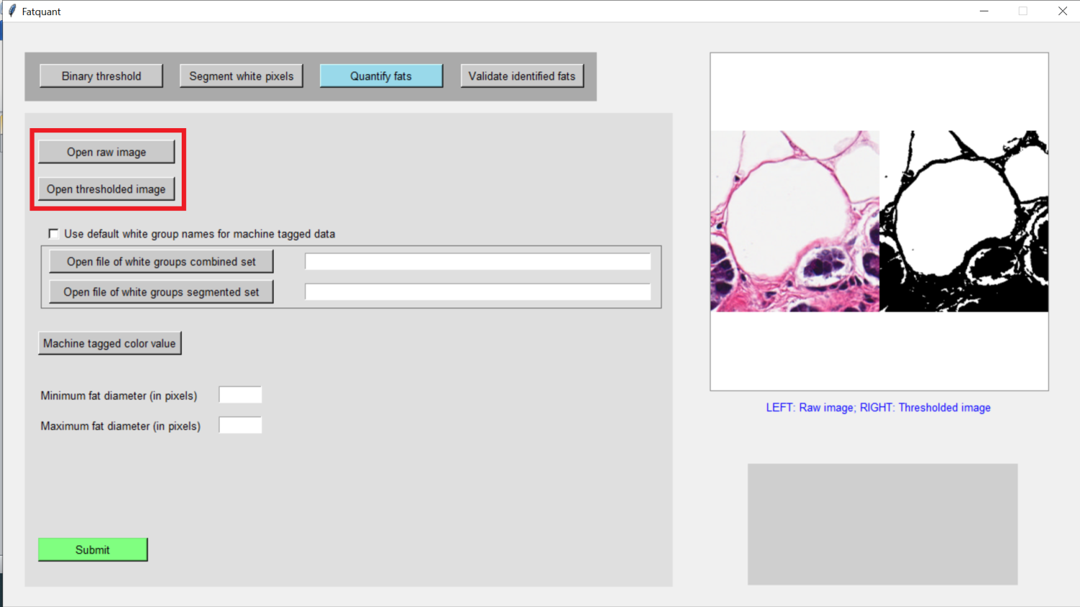

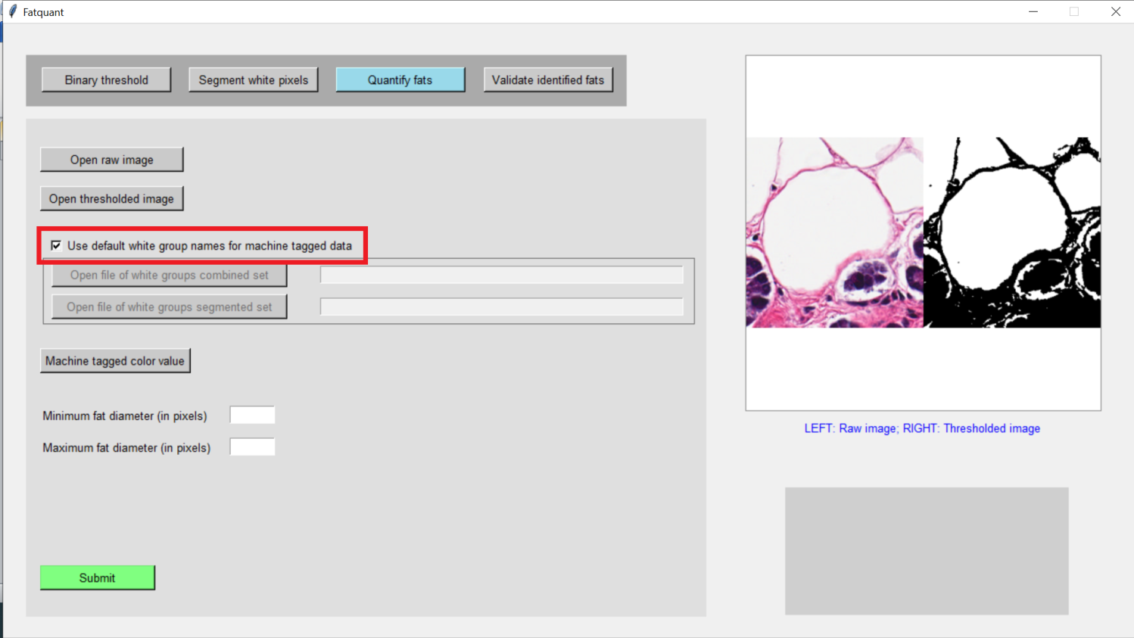

(If in case you have modified default name of files generated after ‘Segment white pixels’ then don’t click on the check box highlighted on the previous step. Instead manually locate the files.)

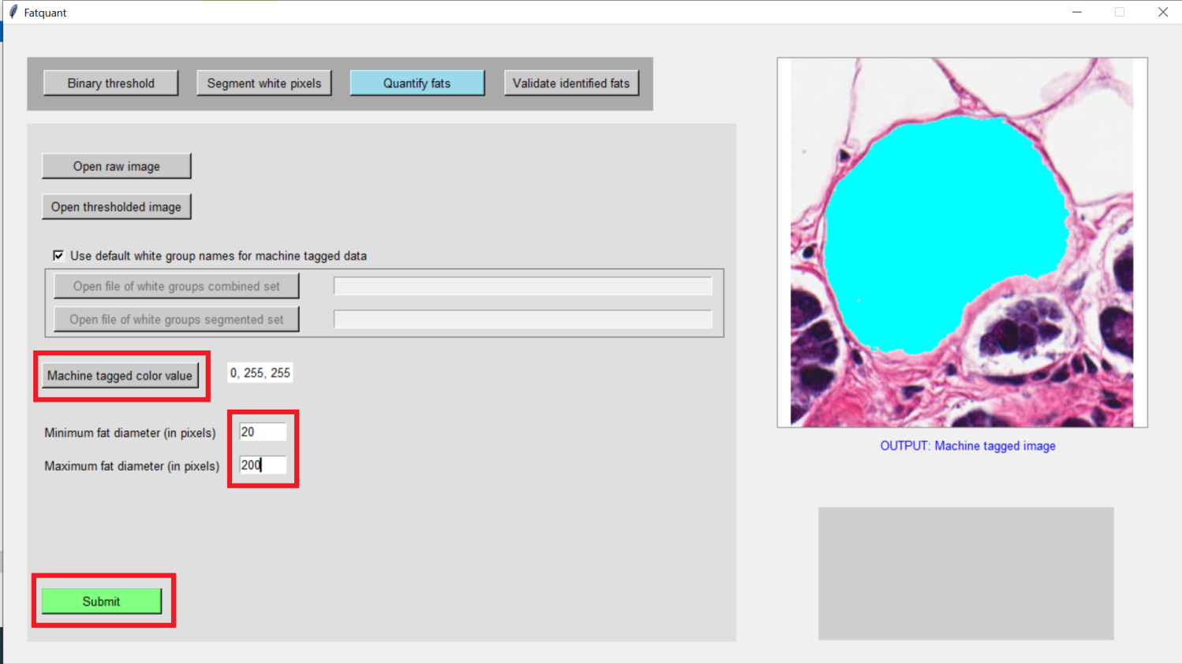

**Validate identified fats**

(If segmentation of white pixels in ground truth data has been done then perform the steps below)

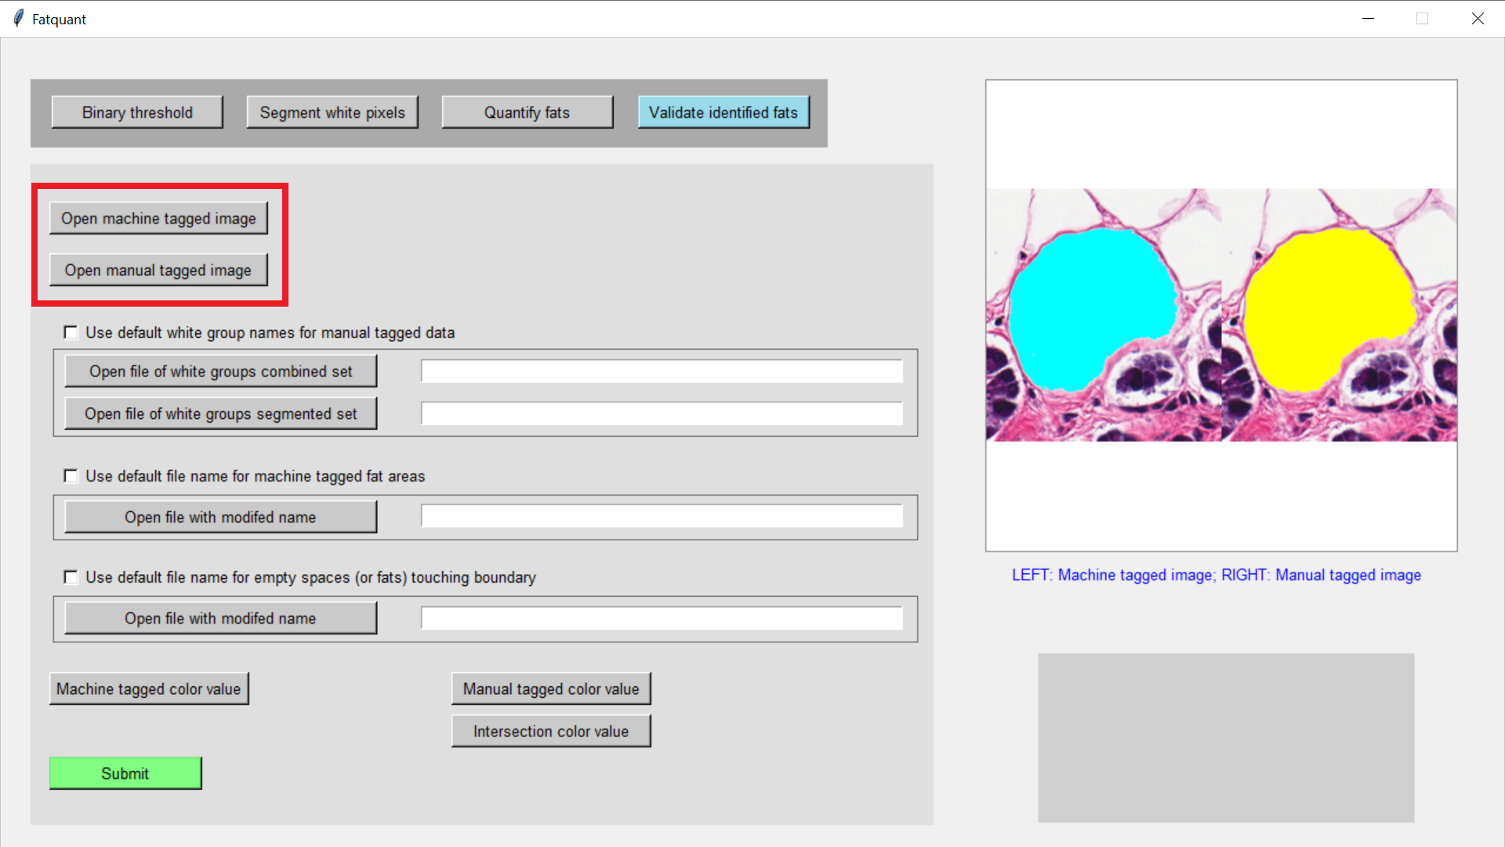

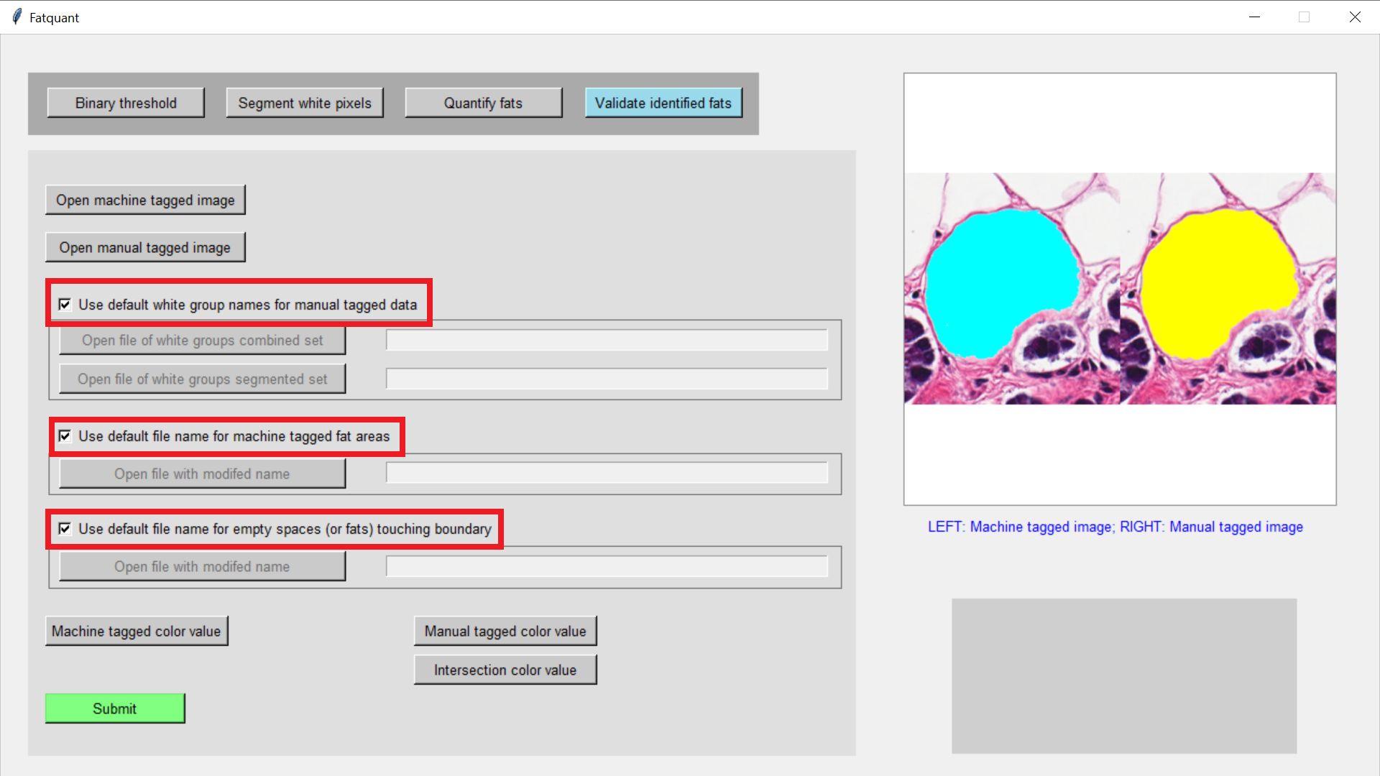

(If in case you have modified default name of files generated after ‘Segment white pixels’ and ‘Quantify fats’ then don’t click on the check boxes highlighted on the previous step. Instead manually locate the files.)

